**Temco Software for development**

1. Build all the projects in solution
2. Right click on T3000 project and set as startup project
3. Install t3000 on pc (some missing packages will be installed on pc)
4. some libcrypto-1_1.dll and libssl-1_1.dll will be missing paste them in (**T3000 Output/debug**) folder

go to main folder and search here for the files

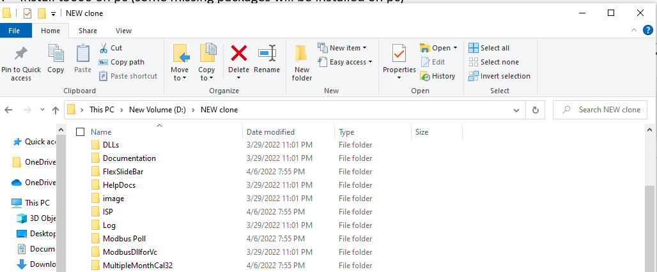

After completion its shown like that

2nd step

1. debug assortion failed C++ mg=fc/occcont.cpp may occur that can be due to flexslideBar project rebuild it after T3000 installation

1. Run as administrator the solution to build all projects.

Select here

Right click here

**For WebView**

1. Microsoft WebView runtime(Microsoft Edge) should be installed on local pc.
2. Uninstall and reinstall Nu get packages:

* Microsoft.Web.WebView2, latest version of PC
* Microsoft.Windows.ImplementationLibrary ,latest version of PC.

**On Aqeeb Branch**

1. Right click on main project file, go to the properties and **uncheck read only option,** then select **apply to folders, subfolders and files** and then okay.

Uncheck here

Right click here

1. To access the property pages, choose **T3000** **> jsoncpp.cpp> Properties** from the main menu, go to **C/C++,** on drop down menu go to **precompiled** **header** and set **not using pre-compiled header**

Right click here

1. To access the property pages, choose **T3000** **> WebView>BacnetWebView.cpp> Properties** from the main menu, go to **C/C++,** on drop down menu go to **precompiled** **header** and set **not using pre-compiled header**

Right click here

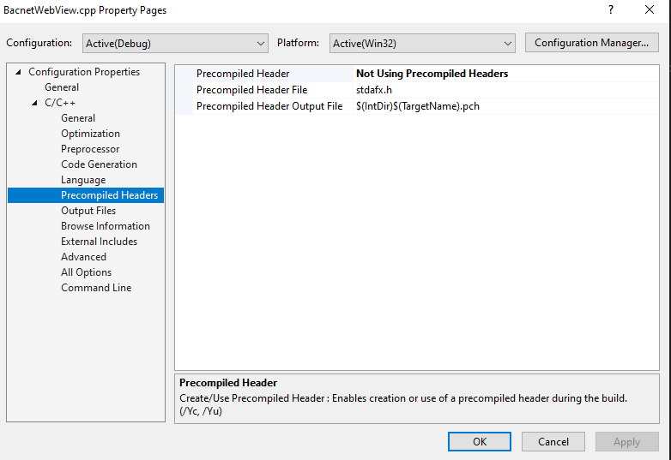

1. Copy and paste **T3000.exe from T3000** folder to **T3000 Output>debug**
2. Search **WebView2Loader.dll** then copy and paste it into **T3000 Output>debug**
3. To access the property pages, choose **T3000** right-click on the file and choose **Properties**., go to **Prepocessor,** on drop down menu go to **General** and click on Additional Include Directories and give this directory given below:**WIN32;_WINDOWS;_DEBUG;SOLUTION_DIR=R"($(SolutionDir))";%(PreprocessorDefinitions)**

Right click here

Include here

1. To access the property pages, choose **T3000>source files>Web View>Bacnet WebView.cpp,** right-click on the file and choose **Properties**., go to **C/C++,** on drop down menu go to **General** and click on Additional Include Directories and give this directory given below:

**$(MSBuildThisFileDirectory)..\..\include\;Json-cpp\include\;%(AdditionalIncludeDirectories)**

Right click here

Include here